PM: Technical solutions for maintenance of NordDRG system
Helsinki 30.6.1999
Martti Virtanen

The NordDRG system will consist of several modules, which together make it possible to use, understand and develop the system in cooperation between the participating countries. Because the countries have different classification systems the national versions of NordDRG will be different although they have common basic structure. The system will also make it possible to test new versions of the grouper in the same environment. The key elements of this process are described in the proposal for rearrangement of the work and Nordic Classification Center.

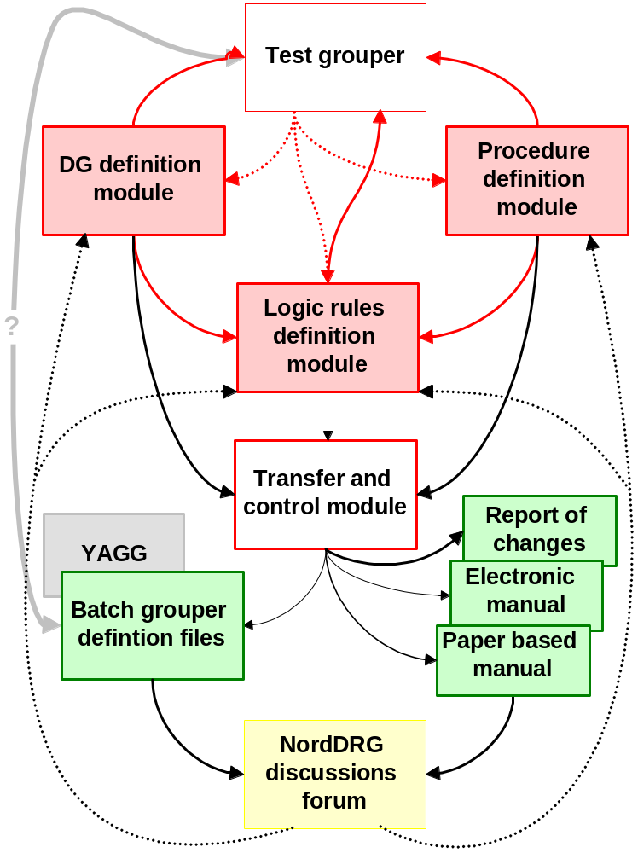
Fig. 1. NordDRG maintenance system
The core of the maintenance system (Fig 1.) are the programs, that are used for handling of the diagnosis property and category definitions (Dg definition module), procedure property definitions (Procedure definition module) and general logical rules of NordDRG (Logical rules definition module).

The diagnosis definition module (Fig. 2) will include a system for changing all the tables of different properties and categories in the system as well as the General diagnosis definition table, which defines each individual diagnosis. Besides this only the table of complication category exclusions includes diagnosis specific information. The system will also be able to update the diagnosis table from a standard dBase-file.

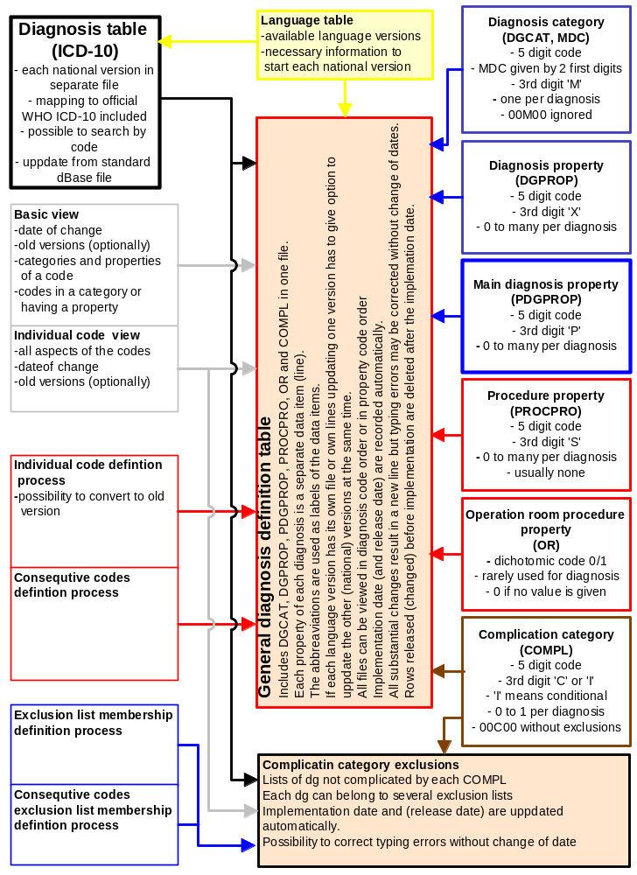
Fig. 2. Diagnosis definition module
The procedure definition module will be somewhat simpler but the basic structure will be similar to Diagnosis definition module and they have will even have some common parts (Fig 3.).

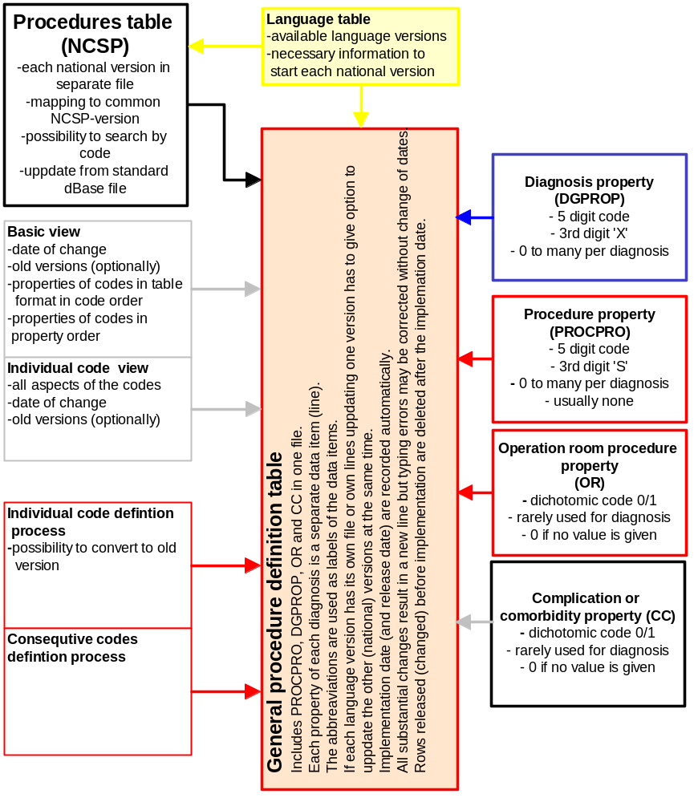
Fig. 3. Procedure definition module

The third central unit of the system will be the Logic rules definition module. Its main functions will be the Definition editor and the Definition reporter. The former is used to define individual rules. Each of them will be represented as one data item (one line) in the table. Definition editor will be the tool for selecting the properties and categories to form the rule in the logic table. The definition reporter will be able to report content of the individual rules to the level that it gives the list of diagnoses and procedures belonging to each property or category group.
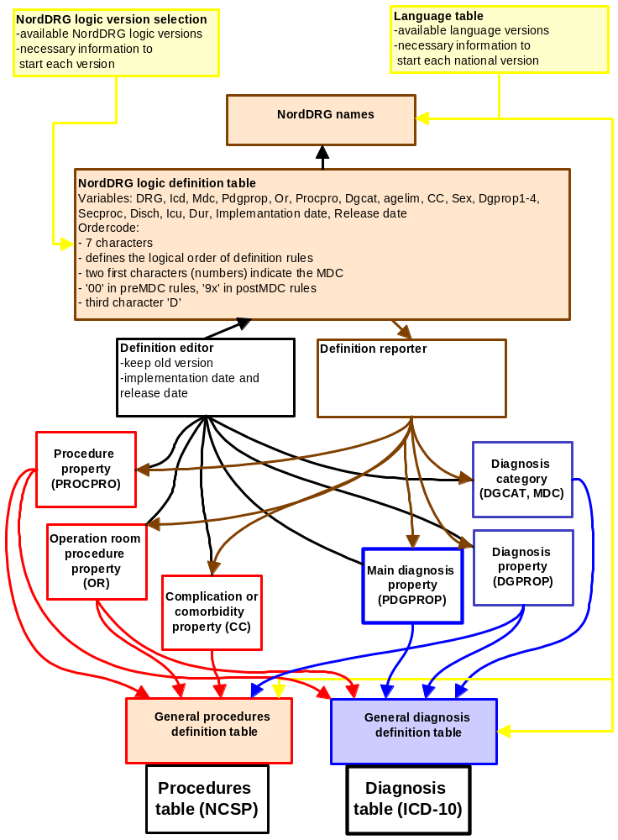

Fig 4. Logic rules definition module

